**Workflow Functional Document**

|  |  |
| --- | --- |
| **Application :** | NGERP CENTRA |
| **Workflow :** | Quote To Cash |
| **Workflow Item Name :** | SG&A Register Promotion Order |

**Description :**

The SG&A Register Promotion Order Transaction Used For SKU’s Sales To Emplyee’s In Sales Order Screen.

**Workflow Process :**

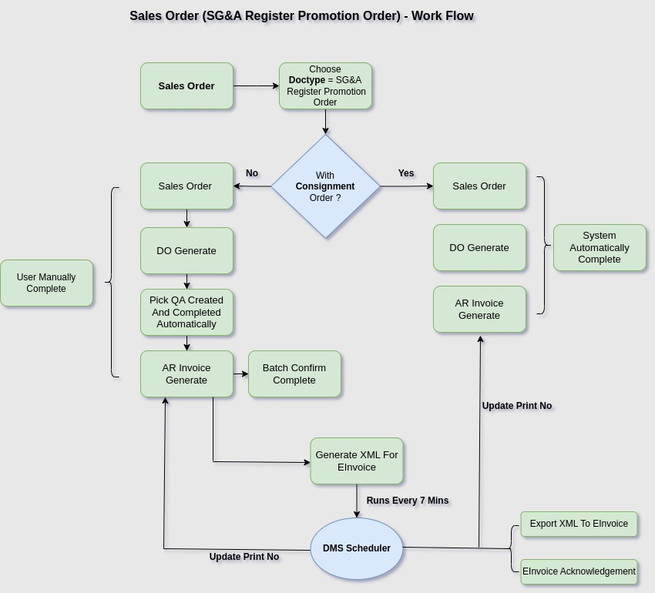

**Business Rules :**

* A Consignment Order Refers To A Sales Arrangement Where A Business (The Consignor) Provides Goods To A Customer (The Consignee) To Sell On Behalf Of The Consignor. In This Case, The Consignee Doesn’t Own The Goods Immediately But Acts As A Sales Agent Or Retailer, With The Consignor Retaining Ownership Until The Goods Are Sold.

**With Consignment Order :**

* Choose Respective Consignment Order.
* Borrow Warehouse Should Be Choosen In Header Screen.
* Save The SO Header And Proceed With Line.
* Choose Respective Products From The Choosen Consignment Order.
* Price Should Be Of Zero.
* Save And Proceed With Order Completion.
* Once Sales Order Is Completed Both DO And Invoice Is Automatically Created And Its In Completed State.
* Payment Is Not Required For This Document Type, By Default IsPaid Is Always Ticked For This Transaction.
* Process The Respective Invoice In Print Batch Invoice Screen.
* Xml File Is Generated And Dms Scheduler Every 7 Minutes Once Process & Export Xml To Specific Location.
* Dms Scheduler Every 7 Minutes Once Process And Updates The Invoice Printno For Respective Invoices.

**Without Consignment Order :**

* Save The SO Header And Proceed With Line.
* Choose Respective Products .
* Price Should Be Of Zero.
* Save And Proceed With Order Completion.
* Once Sales Order Is Completed Proceed With DO Generation In Generate DO From SO Form.
* DO Is Generated In Inprogress State Proceed With Invoice Generation In Generate Invoice From SO Form.
* Once Invoice Is Completed Then Do Is Also Completed.
* Payment Is Not Required For This Document Type, By Default Ispaid Is Always Ticked For This Transaction.
* Process The Respective Invoice In Print Batch Invoice Screen.
* Xml File Is Generated And Dms Scheduler Every 7 Minutes Once Process & Export Xml To Specific Location.
* Dms Scheduler Every 7 Minutes Once Process And Updates The Invoice Printno For Respective Invoices.